Hey Dancers!
Sycamore High School Orchesis Dance Troupe is hosting a clinic for Middle School Students (6-8th)
This is a chance for the students to perform at the ninth annual dance show…
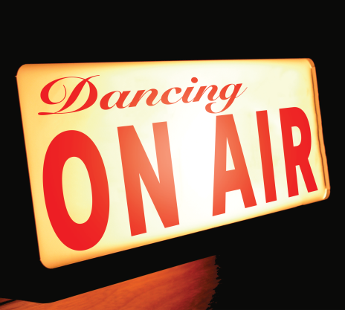
Required Dates
CLINIC DATES: February 12th, 19th, 26th, 4thfrom 3:30 – 4:45pm
Students will be bussed after school from the middle school to high school. Parents need to pick up students at 4:45pm in SHS auditorium. Bussing details will be emailed to parents after registration.

March 11th from 4:30 – 5:45pm - IN COSTUME ON STAGE
Full Dress rehearsal: Wednesday, March 16th at 6:30pm.
Show Nights: March 17th, 18th, 19th @ 6:30p.m. (show time: 7p.m.)
Matinee: March 19th @ 1:30 (show time 2p.m.)

Cost: $75 including costume, clinics, & show shirt

Sign your child up at by visiting the following website:
- Visit website:http://il.8to18.com/sycamorehs
- Click on registration tab, create an account or login if you have an account already
- Enter your email address and create a password
- Click button “Let’s Go!”
- Click on begin registration
- Scroll down to Camps, andchoose activity. (Orchesis Show)
- Read info box then proceed with registration
- Once all info is filled out click on continue to step 3, (anything with a * must be filled out completely)
- Follow remaining steps, the $75 registration fee is required when registering online

Registration form must be completed and paid online by Friday, January 8th to be in the show!

No late registrations will be accepted.

Questions: Please contact Kristin Hill by email at khill@syc427.org

